Name _________________________________ Date_________ Period_______
ESS Hydrosphere Exam Review Sheet

- What percentage of the Earth is covered by water?_____________
- What percentage of Earth’s water is saltwater/ocean?___________
- What percentage of Earth’s water is frozen as ice or glaciers? ________
- What percentage of Earth’s water is available to humans (for drinking)?_________
- The Hydrosphere is defined as __________________________________ ______________________________________________________________________________________________________________________
- Water that collects on the ground is called ________________________
- Water that collects under ground is called ________________________
- A reservoir is a ______________________________________________ ___________________________________________________________
- A glacier is a ________________________________________________ ___________________________________________________________
- List the 4 major steps of the water cycle and include a brief description
  - _____________________ - ______________________________ ____________________________________________________
  - _____________________ - ______________________________ ____________________________________________________
  - _____________________ - ______________________________ ____________________________________________________
  - _____________________ - ______________________________ ____________________________________________________
- An underground reservoir that holds water is called an ______________
- Water flowing over the land is referred to as ______________________
- How are oceans important to the water cycle? ____________________
- How do oceans distribute heat on the Earth? ______________________ ___________________________________________________________
- Why are climates on the coastline usually milder than climates inland? ______________________________________________________________________________________________________________________
- What are gyres ______________________________________________ ___________________________________________________________
- What is infiltration? __________________________________________
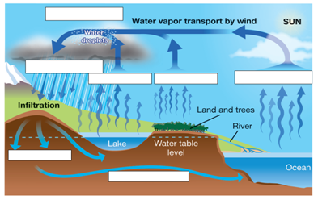
18-25. Label the above diagram using the following terms… (some terms may be used twice);
  - Evaporation, condensation, transpiration, precipitation percolation, groundwater transport
26. Which moves more slowly, surface currents or deep ocean currents
_____________________________
22. What is the abyssal plain? _________________________________________
28-39. Label the two diagrams below
