Name ______________________________________ Date________ Per______
ESS Using notes Worksheet: Oceans
- List the 5 oceans that cover the Earth
  - ____________________________
  - ____________________________
  - ____________________________
  - ____________________________
  - ____________________________
- The measure of dissolved salt in ocean water is usually referred to as ______________________________
- Oceans are able to store large amounts of ____________________
- Large rotating systems of surface ocean currents are called ______________
- Which move faster?; surface ocean currents or deep ocean currents? _______________________________________
- The ocean region around the continents is called the ________________________________ and includes the following 3 features
  - _______________________________________
  - _______________________________________
  - _______________________________________
- The “true” ocean floor is called the ___________________________________________
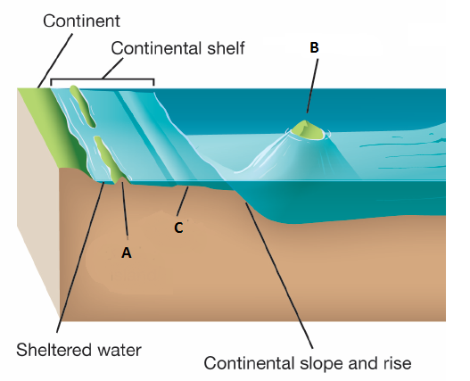
8-10. Label A, B, and C in the diagram below
A =

B =

C =

- The deepest parts of the ocean are referred to as ______________________________________________

- Seamounts whose tops have been eroded so they no longer stick out of the ocean are called _____________________________________

- The boundaries between two plates that are moving away from each other at the bottom of an ocean that forms and underwater mountain range are known as _________________________________________

- How is the ocean important for the water cycle? ___________________ ____________________________________________________________________________________________________________________________________________________________________________________________________________________________________________

- How does the ocean help regulate the temperature of Earth? _______________________________________________________________________________________________________________________________________________________________________________________________________________________________________________________________________________________________________

