Name__________________________________________________
Water Cycle Diagram matching

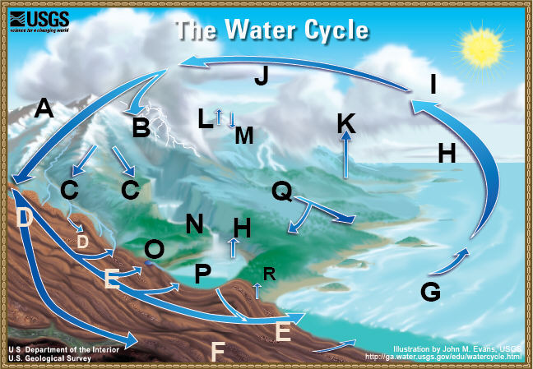
Water-cycle terms
[ ] Condensation | [ ] Evaporation
[ ] Evapotranspiration | [ ] Freshwater storage
[ ] Groundwater discharge | [ ] Groundwater storage
[ ] Infiltration | [ ] Precipitation
[ ] Snowmelt runoff to streams | [ ] Spring
[ ] Streamflow | [ ] Sublimation
[ ] Surface runoff | [ ] Water storage in the atmosphere
[ ] Water storage in ice and snow | [ ] Water storage in oceans
[ ] Desublimation | [ ] Plant uptake

